**RPPA Network Analysis EDA (Workflow) SOP**

Last edited: 12/04/2023

Written by: David Tek

Collaborators: Virginia Espina, Mariaelena Pierobon

**Context**

This workflow is for the analysis of data collected from reverse-phase protein array (RPPA) experiments, with control and experiment groups. The Jupyter Notebook script (available for use locally or through Google Colaboratory) take the RPPA data in the form of a CSV file and calculates the statistical significance of each endpoint (protein). The results of the analysis are then made available in the Jupyter Notebook output cells and in the form of a network visualization in Cytoscape (an open-source network visualization software).

**Requirements**

Files

All required files and examples files are in the GitHub repository linked below.

<https://github.com/dtek-projects/RPPA-Workflow>

For Google Colaboratory and Local use:

Cytoscape 3.10.1 or later, installed on user’s computer.

Google Chrome, Mozilla Firefox, or Microsoft Edge

For Local use:

Jupyter notebook v2023.4.1011241018 or later

Python 3.10.9 or later

Python packages:

py4cytoscape

pandas

NumPy

SciPy

**Support**

Contact David Tek ([dtek@gmu.edu](mailto:dtek@gmu.edu)) or create an issue on the GitHub repository for questions, to report a bug, or to request a feature (no response or resolution time guaranteed).

**Instructions**

The Endpoint_data.csv and Network_map.csv files must be formatted as the example file are for the script to work. The two files must also be exactly named Endpoint_data.csv and Network_map.csv unless you are comfortable editing Python scripts. Below are explanations of the two files’ formats.

CSV file formats

Endpoint_data.csv (See image below)

*If the RPPA experiments used replicates outliers and errors should be removed before the data is averaged and added to the Endpoint_data.csv file.

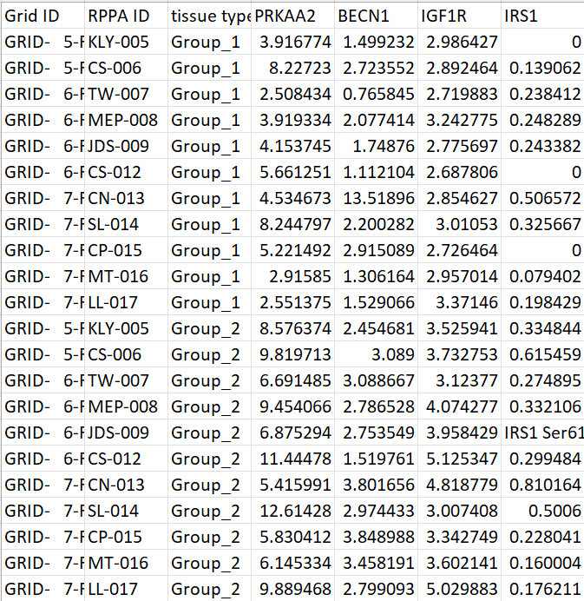

Columns:

1. Column A | Grid ID – This column contains the location on the slide the endpoint data was collected from. This column is not utilized in the script so it can be edited.
2. Column B | RPPA ID – This column contains the name of the sample/slide/experiment subject the data was collected for. This column is not utilized in the script so it can be edited.
3. Column C | Tissue type – This column contains the identifier for which experimental group the sample data is for. In this context Group_1 is the control group and Group_2 is the experimental/treated group. The spelling for Group_1 and Group_2 must be exact for the script unless you are comfortable editing Python scripts.
4. Columns D and forward – These columns contain the numerical values of the experiment samples collected via the RPPA process.

**\*Column names for Columns A, B, and C do not matter and can be edited. However, Column names for Columns D and later must be correctly formatted as gene names.**

**How to get the gene names**:

1. The contents of Rows 2 and greater should be of a numerical value. If a non-numerical value is detected it will be removed and the cell will be imputed by the smallest value in the column of the endpoint and of the group (Group_1 or Group_2) that the cell belongs to divided by 2.
2. The contents of Row 1 should be the gene name of the endpoint/protein. The gene name must be the name used in the STRING database. This gene name can be obtained by querying the STRING database using the name of the endpoint/protein (See image below).

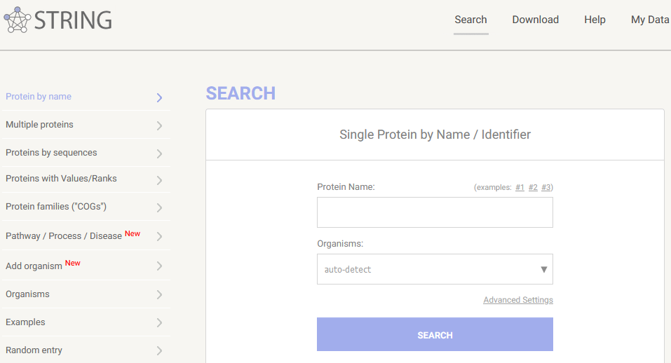

**How to edit Endpoint_data.csv**

1. Confirm that you have data for a control group and an experimental group.
2. Confirm that you have the exact same samples in the control group and the experimental group.
3. As per the above descriptions of the columns, the contents for Columns A and B can be whatever identifies you prefer to keep track of your sample IDs.
4. For Column C, assign each row to Group_1 if the data is for a control sample and to Group_2 if the data is for an experimental sample.
5. For Columns D and onward, the column title should be the gene name (see “How to get the gene names” above) and each row in the column should be the protein quantification value or gene expression value for each sample.
   1. If replicates were used, this value should be the average after normalization.

Network_map.csv (See image below)

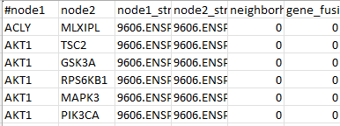

Columns:

1. Columns A and B – These columns contain the pairs of gene names used to link the genes in the network visualization. These columns are utilized by the script so the spelling of the gene names should match the spelling of the gene/endpoint/protein column labels in the Endpoint_data.csv file.
2. Columns C and forward – These columns contain numerical values that indicate how the genes are related according to the STRING database. These columns are not utilized by the script.

**How to generate the Network_map.csv file**:

* 1. Convert all endpoint/proteins to gene names the STRING database uses.
  2. Use STRING database’s “Multiple proteins” query. (See image below).
     1. Paste the gene names in a list with one gene per line.
     2. Select the correct organism based on which organism your samples were collected sourced from.
     3. After pressing search. A list will appear to have you select which genes you want to use as some genes have different variations.
     4. The next screen will have an interactive network visualization with a legend.
     5. Go to the “Settings” tab below the network visual.
     6. In the “Basic Settings” section and “active interaction sources:” subsection, uncheck all the boxes except **Experiments** and **Databases**. (See image below).
        1. This filters the network so only known protein-protein interactions are shown on the network.
     7. Click the blue “UPDATE” button on the right side.
     8. Once you have the network visual filtered go to the “Exports” tab below the network visual.
     9. Click the “download” button for the “…as short tabular text output” to get a TSV file containing the network interactions. Save this file to your computer.
     10. Open the TSV file with Excel to convert it. Save this file as a “CSV UTF-8 (Comma delimited)” file.

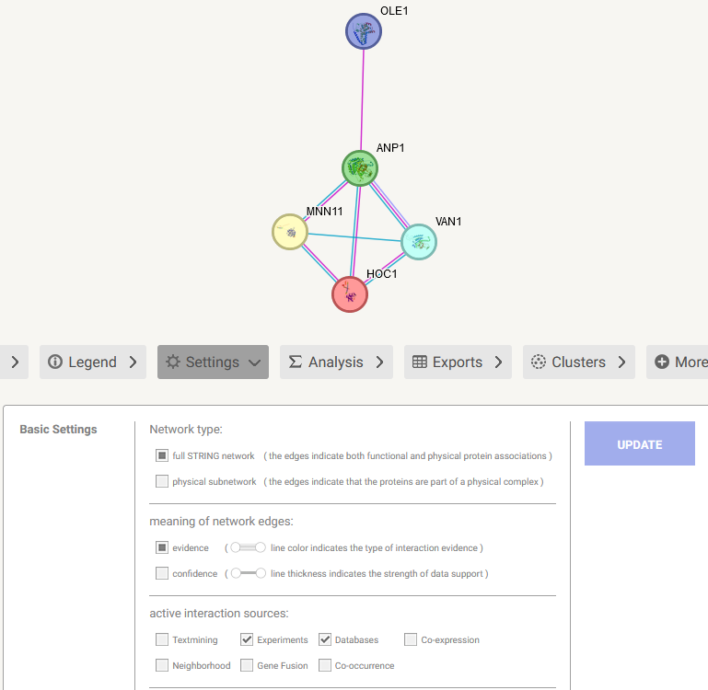

How to use:

Instruction on how to use the RPPA Network Analysis EDA (Workflow) can be found below or within the Jupyter Notebook script.

On Google Colaboratory:

1. Start the Cytoscape software on your computer.
   1. You will not need to look at Cytoscape until the workflow finishes.
2. Go to https://colab.google/ in Google Chrome/Mozilla Firefox/Microsoft Edge.
3. Click Open Colab.
4. Sign in using a Google/Gmail account.
5. Click file (in the top left) and select “Upload notebook”.
6. Select or drag the “RPPA_Network_Analysis_EDA_Colab.ipynb” Jupyter Notebook file to the “Open notebook” window.
   1. The “.ipynb” file extension indicates it is a Jupyter Notebook file
7. Scroll down so that you can see both text boxes that say “2.B: Select CSV file containing network structure information” and “2.C: Select CSV file containing endpoint data”.
8. Go to the “Runtime” tab in the top left corner.
9. Press “Run all”.
10. Allow the code blocks to run. You will see a rotating circle while the code blocks are running.
    1. **Do not click any of the “play” buttons.**
    2. If you do you will need to restart the process by going to the “Runtime” tab and selecting “Disconnect and delete runtime”. Then start code again by going to the “Runtime” tab and selecting “Run all”.
11. When the code cell below “2.B: Select CSV file containing network structure information” is running, a grey box that says “Browse” or “Choose file” will appear. Click it and **select your “Network_map.csv” file**. Then wait until the block finishes running.
    1. When the block finishes running a table with the contents of the CSV file will appear below the block.
12. When the code cell below “2.C: Select CSV file containing endpoint data” is running, a grey box that says “Browse” or “Choose file” will appear. Click it and **select your “Endpoint_data.csv” file**.
    1. When the block finishes running a table with the contents of the CSV file will appear below the block.
13. Let the rest of the code cells run.
14. Scroll to the bottom of the screen to monitor the program run process.
15. When all the code cells have completed, the network visualization will appear at the bottom of the Jupyter Notebook and in the Cytoscape application.
16. Save your Google Colab file.
    1. Go to File. Click Save.
    2. You can rename the Google Colab file by double-clicking the “RPPA_Network_Analysis_EDA_Colab.ipynb” at the top of the screen. But you must use the file extension .ipynb.

On your computer (Locally): **[Only recommended for programmers]**

**\*See Appendix B for first time setup**

1. Start the Cytoscape software on your computer.
   1. You will not need to look at Cytoscape until the workflow finishes.
2. Open the “RPPA-Network-Analysis-EDA.ipynb” Jupyter Notebook file in your preferred Integrated development environment (IDE). **[Visual Studio Code recommended]**
3. Run all the code cells.
   1. This can be done in Visual Studio Code by pressing “Run All”.
   2. Or by manually pressing the “Run”/Play button next to each code cell.
4. As the code cells run, two file explorers will pop-up.
   1. For the first one, select the file that you have formatted to match the Endpoint_data.csv example file.
   2. For the second one, select the file that you have formatted to match the Network_map.csv example file.
   3. **Sometime the file explorer will open behind all other windows you have open.**
5. Let the rest of the code cells run.
6. When all the code cells have completed, the network visualization will appear at the bottom of the Jupyter Notebook and in the Cytoscape application.

**Appendix A**

How to handle two gene variants in the dataset

In the example files, there were two variants of EGFR (EGFR Y1101 and EGFR Y1148). In the event your dataset has two variants of the same gene follow the below steps.

1. Follow the instructions to assemble the Endpoint_data.csv and Network_map.csv files as previously described.
   1. On the STRING database website, the plain gene name (Ex: EGFR) should be selected and added to the network.
2. After exporting the TSV file from STRING database and converting it to a CSV file. Open the CSV file and find all occurrences of the specific gene that are listed in columns A and B.
3. Add a variant identifier to the end of each existing entry for the gene (Ex: EGFR Y1101).
4. Copy the rows in both columns A and B where the gene entry exists with its associated gene/protein/endpoint.
5. Paste these copied cells below the last row in the table. (See image below).
6. Replace the variant identifier in these copied cells with a second unique variant identifier (Ex: EGFR Y1148). You do not need to populate the other columns with information. (See image below).

**Appendix B**

First time installation for Cytoscape:

1. Go to <https://cytoscape.org/>
2. Click “Download”.
3. On the download page download the suggested version for your system (Windows/MacOS/Linux) by clicking the big orange button.
4. Wait for the .exe file to download.
5. Run the .exe file and accept the default options.

First time installation for **Local** version of workflow:

1. Install Visual Studio Code.
   1. From: <https://code.visualstudio.com/>
   2. Accept all default options.
2. Open Visual Studio Code.
3. Go to “File” and select “Open File…”
4. Select the “RPPA-Network-Analysis-EDA.ipynb” Jupyter Notebook file.
5. On the left side of the window click the “Extensions” button that looks like 4 squares.
6. In the extension tab that opens, look for the extension pack that is called “Python” (it has a blue and yellow logo that looks like snakes). Click the install button.
7. Also, find the extension pack called “Jupyter” (its logo says Jupyter with two orange crescents) and click the install button.
8. Now to install the required Python packages:
   1. In visual studio code, go to “Terminal” in the top left and select “New Terminal.” A new sub window will appear at the bottom of the Visual Studio Code window.
   2. Install Pandas by copying the command “pip install pandas” (do not copy the quotations) and paste in in the terminal window and press enter. **Let it run until it finishes the installation.**
      1. Pandas automatically installs NumPy.
   3. Install py4cytoscape by copying the command “pip install py4cytoscape” (do not copy the quotations) and paste in in the terminal window and press enter. **Let it run until it finishes the installation.**
   4. Install Scipy by copying the command “python -m pip install scipy” and paste in in the terminal window and press enter. **Let it run until it finishes the installation.**
9. Now you should have everything you need to run the RPPA Network Analysis EDA Workflow locally.
   1. If during the first run of the workflow Visual Studio Code ask you to install another Jupyter notebook extension press “Yes”/”Install”.

**References**

Coarfa, C., Grimm, S. L., Rajapakshe, K., Perera, D., Lu, H. Y., Wang, X., Christensen, K. R., Mo, Q., Edwards, D. P., & Huang, S. (2021). Reverse-Phase Protein Array: Technology, Application, Data Processing, and Integration. *Journal of biomolecular techniques : JBT*, *32*(1), 15–29. <https://doi.org/10.7171/jbt.21-3202-001>

Harris, C.R., Millman, K.J., van der Walt, S.J. et al. Array programming with NumPy. Nature 585, 357–362 (2020). DOI: 10.1038/s41586-020-2649-2.

Kluyver, T., Ragan-Kelley, B., Pérez, F., Granger, B., Bussonnier, M., Frederic, J., Kelley, K., Hamrick, J., Grout, J., Corlay, S., Ivanov, P., Avila, D., Abdalla, S., Willing, C., & team, J. development. (2016). Jupyter Notebooks—A publishing format for reproducible computational workflows. In F. Loizides & B. Scmidt (Eds.), Positioning and Power in Academic Publishing: Players, Agents and Agendas (pp. 87–90). IOS Press. <https://eprints.soton.ac.uk/403913/>

McKinney, W. (2010). Data Structures for Statistical Computing in Python. In S. van der Walt & J. Millman (Eds.), Proceedings of the 9th Python in Science Conference (pp. 56–61). <https://doi.org/10.25080/Majora-92bf1922-00a>

Otasek, D., Morris, J. H., Bouças, J., Pico, A. R., & Demchak, B. (2019). Cytoscape Automation: empowering workflow-based network analysis. *Genome biology*, *20*(1), 185. <https://doi.org/10.1186/s13059-019-1758-4>

Shannon, P., Markiel, A., Ozier, O., Baliga, N. S., Wang, J. T., Ramage, D., Amin, N., Schwikowski, B., & Ideker, T. (2003). Cytoscape: a software environment for integrated models of biomolecular interaction networks. *Genome research*, *13*(11), 2498–2504. <https://doi.org/10.1101/gr.1239303>

Szklarczyk, D., Kirsch, R., Koutrouli, M., Nastou, K., Mehryary, F., Hachilif, R., Gable, A. L., Fang, T., Doncheva, N. T., Pyysalo, S., Bork, P., Jensen, L. J., & von Mering, C. (2023). The STRING database in 2023: protein-protein association networks and functional enrichment analyses for any sequenced genome of interest. Nucleic acids research, 51(D1), D638–D646. <https://doi.org/10.1093/nar/gkac1000>

Van Rossum, G., & Drake, F. L. (2009). Python 3 Reference Manual. Scotts Valley, CA: CreateSpace.

Virtanen, P., Gommers, R., Oliphant, T. E., Haberland, M., Reddy, T., Cournapeau, D., Burovski, E., Peterson, P., Weckesser, W., Bright, J., van der Walt, S. J., Brett, M., Wilson, J., Millman, K. J., Mayorov, N., Nelson, A. R. J., Jones, E., Kern, R., Larson, E., … SciPy 1.0 Contributors. (2020). SciPy 1.0: Fundamental Algorithms for Scientific Computing in Python. Nature Methods, 17, 261–272. <https://doi.org/10.1038/s41592-019-0686-2>